***EQUIFAX***

CMS Fusion

**DATA MENU**

**DOCUMENTATION**

**Revision History**

| **Revision** | **Author** | **Date** | **Status and Description** |
| --- | --- | --- | --- |
| 1.0 | UST Global | 11/07/2017 | Initial Draft |
| 1.1 | Equifax | 11/16/2017 | Review |
| 2.0 | UST Global | 11/17/2017 | Review Comments Incorporated |

Table of Contents

Data Menu 2

1. Data Menu Home 2

2. Process Name 3

3. Data Origin 4

4. Product 5

5. State/Zip Code Input 6

6. Autopilot & Score Models 8

7. Configure ID Scan 12

8. Configure DE Standard 13

9. Double check 14

10. Data menu Filter and Configuration page 15

11. Credit Input 17

12. Summary 20

# Data Menu

The Data Menu process is where we actually poll the credit file or other data sources via Data Pump. It is in this process we apply the initial criteria to the records found in Source Match, and calculates the attributes and scores to be used in the subsequent processes.

## Data Menu Home

All the Data Menu processes created for the current project are listed in the Data Menu’s home screen.

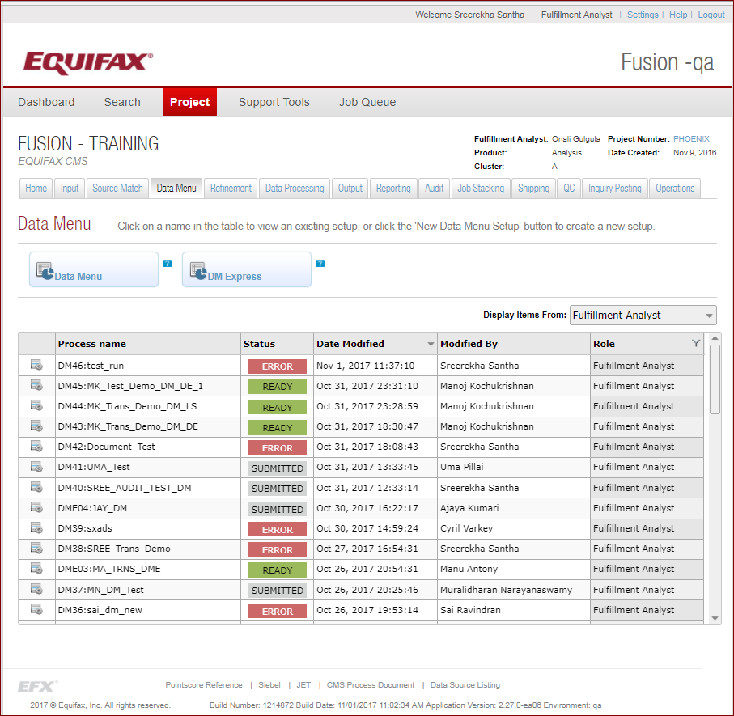

By clicking on the **Data Menu** or **DM Express** option we can create a new Data Menu process.

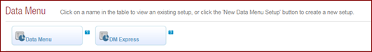

The DM Express option is used for a quick Data Menu process creation. It’s a compact form of the Data Menu option. There are 12 different steps involved in the Data Menu process.

All the Data Menu processes are detailed in the Data Menu grid. Some of the fields of the grid are explained below.

* **Process Name**: All the Data Menu process names are displayed in this column.
* **Status**: Data Menu process has following valid statuses displayed in different colors:

1. *Submitted* (no color) – When the process is submitted successfully without any error, then this status is displayed.
2. *Ready (green)* – The process is saved and is ready to run.
3. *Warning (yellow)* – Currently not displayed.
4. *Error (red)* –When any issue occurs (like no module is selected), this status is displayed

* **Date Modified**: Date & time when the process is last modified in military format
* **Modified By:**  Name of the person that performed the last edit on the corresponding process.
* **Role:** This is the role of the user that created the process. The role for a process remains the same even when edited by a user with a different role. Possible roles are Fulfillment Analyst/Programmer/QC

## Process Name

Here, we need to enter the Data Menu process name. The screenshot of the same is shown below.

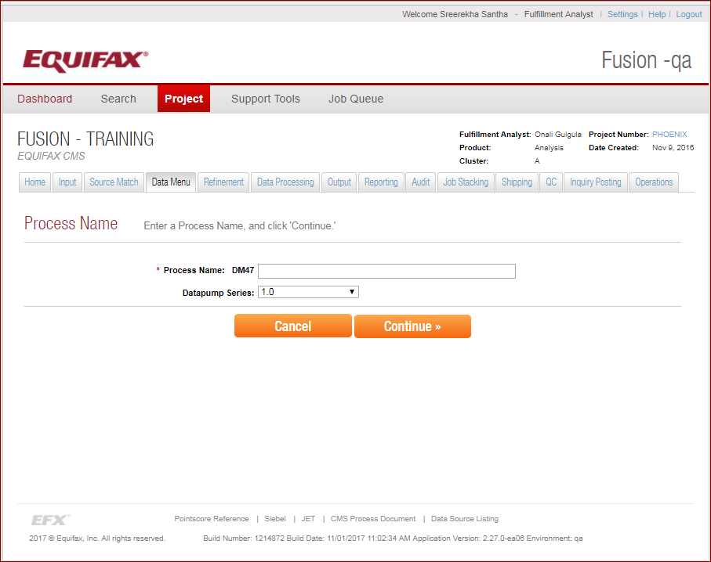

The **Process name** is divided into 2 main parts. The first part of the process name is assigned by the system and the second part is entered by the user. The first part consists of a constant “DM” followed by a two-byte sequence number beginning with 01 and increasing incrementally by 1 with each new process created.

Currently, the **Data pump Series** is 1.0. A new version of DP series is under construction which is 2.0 [Sumerian]

## Data Origin

It’s specifying the origin of the records to be processed. It can be a direct extraction, list source, CID List and Pre-Select.

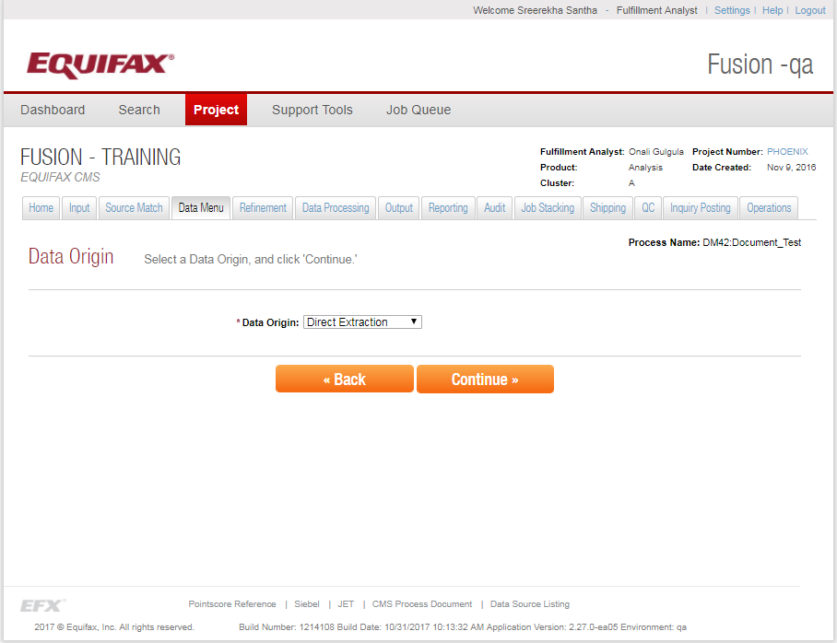

Different options available in the data origin are as follows:

* **Direct Extraction** – The input to the DM process is the entire credit database.
* **List Source** – Out put file from the Source Match is used as the input to the Data Menu
* **CID List** – The input is a file containing a list of CIDs which identifies which credit records to process.
* **Pre Select** – Prescreening the records based on some criteria [e.g. Age, Gender, Hispanic indicator, State, and Zip code] before interacting with Data Pump. A separate database which contains the above said criteria’s will be used to obtain a list of CIDs prior to calculating scores, attributes, and credit decisions in the Data Pump job.

Depending upon the options selected in the Data Origin drop down, the subsequent pages may change.

*[***For the current documentation I have selected the Data Origin as* ***Direct Extraction]***

## Product

The Product page specifies the purpose the current Data Menu process.

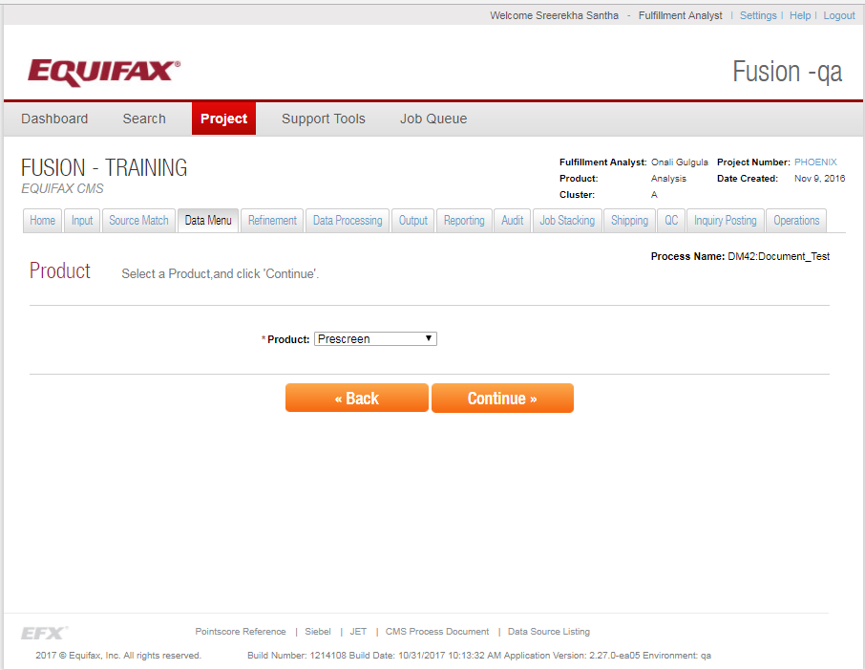

There are various options available in the Product dropdown. They are explained as follows:

* **Prescreen** – Prescreening the data for the acquisition of new customer
* **BPR** – A type of Portfolio review. These are specific to jobs processing data from the **NCTUE** database.
* **BPA** – A type of Account Monitoring. These are specific to jobs processing data from the **NCTUE** database.
* **Customer Port Folio Review** – Reviewing the existing customer’s portfolio.
* **Data Feed** – Currently not used

Depending upon the option selected in the Product, the subsequent pages may change. For the current documentation I have selected **Prescreen.**

## State/Zip Code Input

Provides the provision to select against which geographical area we need to extract the data. Either we can provide Zip Code list or select state else both.

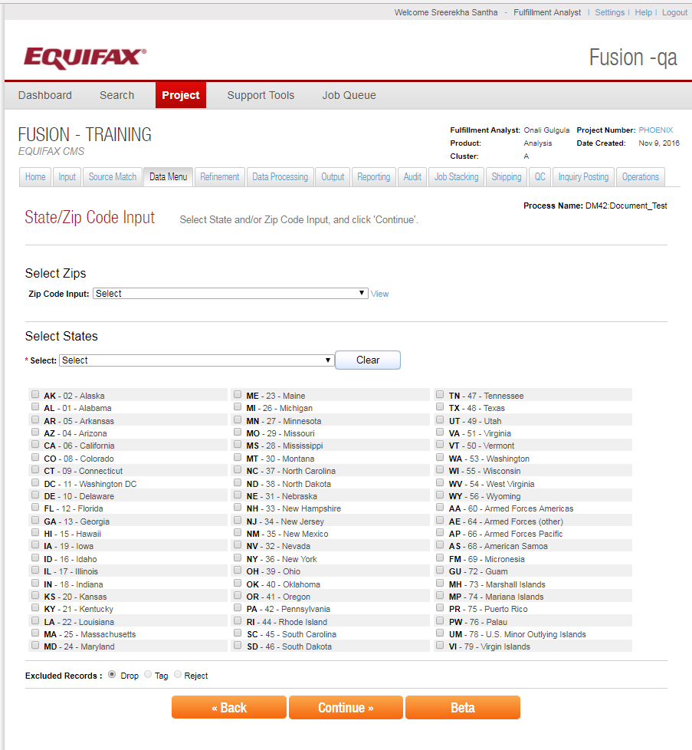

**Select Zips**

We can provide a list of zip codes, so that the Data Menu process will run on those zip codes alone.



**Select States**



We can provide a list of states as input so that the Data Menu process will run on that states alone. We can also select the States in the States grid provided

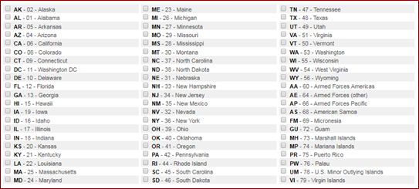

**Exclude Records**



Says what action needs to be performed on the failed records which doesn’t satisfy the geographical selections made. Below are the options available.

* **Tag** – Tag the rejected records and continue process.
* **Reject** – Keep the records but don’t process the rejected records further.
* **Drop** – Remove the rejected records and do not process further on those records. Default selected.

## Autopilot & Score Models

Screen has provision to select the auto pilot modules and the Score models to be applied in the data pump for the current data menu process.

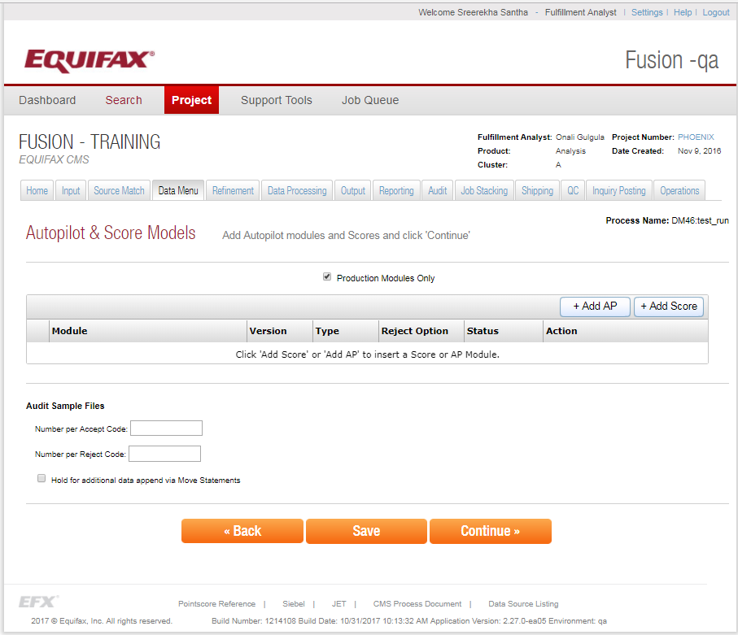

Auto pilot modules calculate the attributes. The screen has provision to select the autopilot module to be applied in the data pump.

**Production Modules Only**



By default it’s checked. If checked means, only the modules deployed in the production directory will be available in the subsequent screen. For programmers to test their AP modules deployed in the test environment, make sure the checkbox is unchecked so that both development and production deployed modules will be available for selection in the next screens. On the other hand if unchecked, it first checks the development library for modules, if it’s not present then the production will be scanned.

**Add AP**

After we add the Auto Pilot, it has the provision to select the auto pilot modules from the list of available modules.



We can have multiple auto pilot modules added in the data menu and click Save.

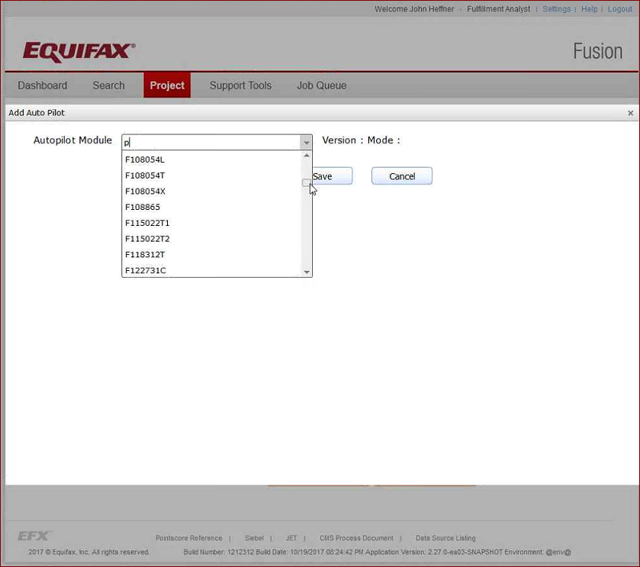

Once the appropriate module is selected, click on the Load button which can load the following:

* **Version:** The current version of auto pilot module deployed.
* **Mode:** Whether it’s Production or DEV.
* **Reject Options:** What to be done on the records which were failed in the auto pilot criteria. Default is Drop.
* **Module Output:** The output map name.

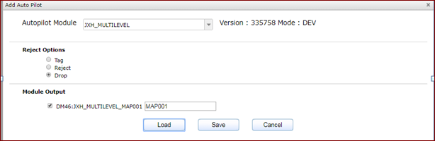

Some Autopilot modules may depend on some external files, means in order to calculate the attribute in AP module it may require some inputs from other files. Below screen shows AP module which has dependency on external files.

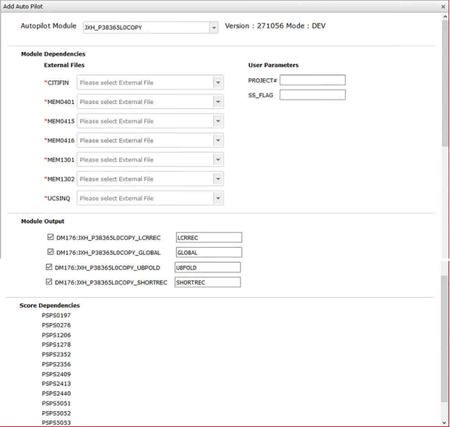

There is an *External File Manager* tool, which boards the external files to fusion system. Once it is boarded, those files will be available for selection in the *External Files* drop down

**Score dependencies** shows on which score models this AP modules depend. All the listed score models will be added to the process.

**Add Score**



There are different score models that have been created to score customers based on their history. Different score models can be selected like Fico score model, Equifax score model etc.

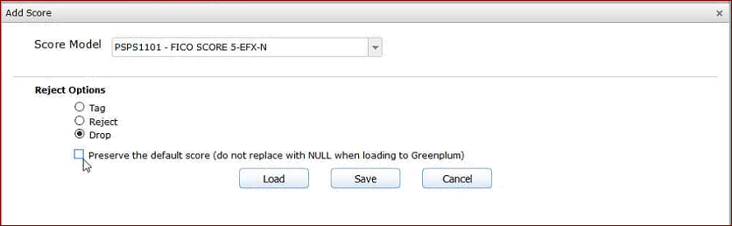

**Audit Sample Files**

Audit sample files are the printed report of credit files, to test and verify the various details (E.g. Are the attributes, calculated correctly or not?). In this section we opt whether we require the sample audit file (input for audit application) and how many ACCEPTS and REJECTS expected per level [A, B, C ...] in the audit sample file. With the sample file process in audit, we get credit data on sample files.

After selecting a process, job and data, we can choose how many records we require for a particular accept level or reject level.

We can also select the hold for additional data append via move statements that prevents the sample files from being delivered to the Audit tool.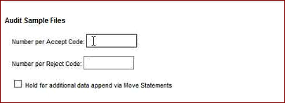

## Configure ID Scan

Customers may be flagged on the basis of suspicious activity. This sections checks whether the identity of the person is dependable or not.

Based on the selection those customers with suspicious identity will be dropped/tagged/rejected from the list, accordingly. The customers having one or more flags like deceased or misused SSN can be dropped from the output list.

The screenshot of the same is shown below.

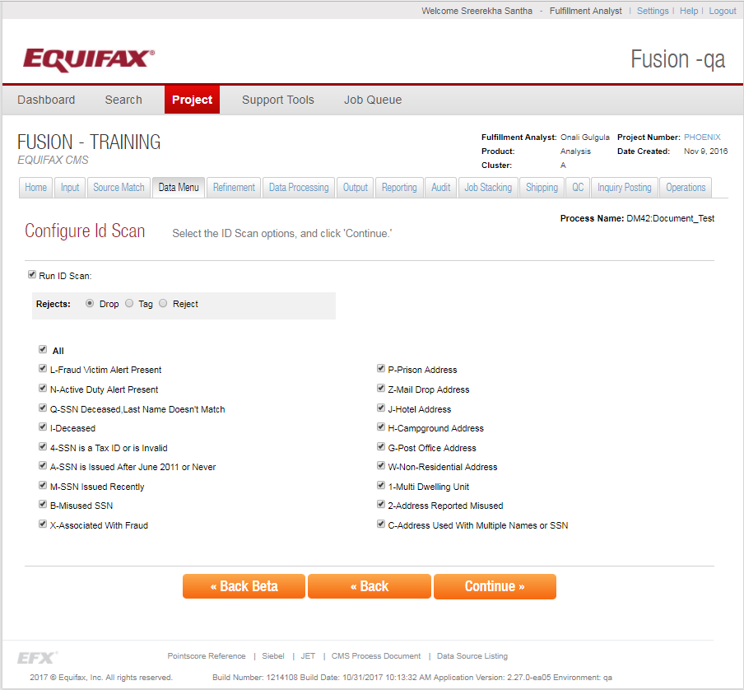

## Configure DE Standard

Here, it involves the configuration of the Direct Extraction Standard.

We can check this option to pull records that meets the minimum requirements. For example, the ones having source rule as at least 2 (information about a person from at least two different sources [Trade line or inquiry]) and the activity range within 6 months etc.

The screenshot of the Data Menu’s DE Standard configuration is shown below.

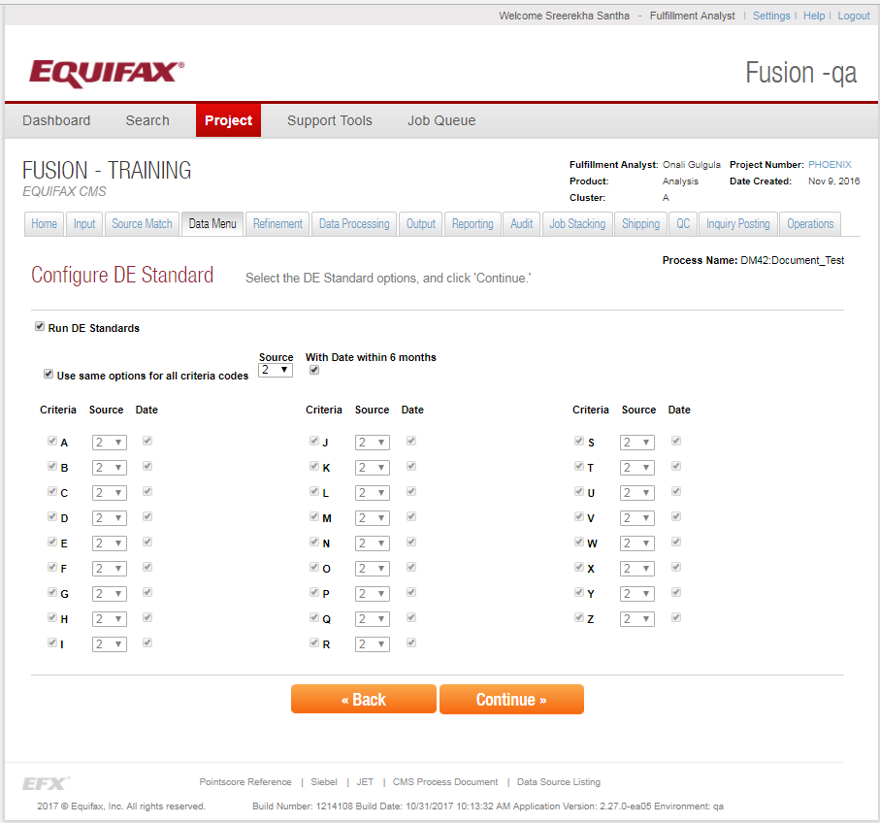

## Double check

It contains a checkbox - Run Doublecheck. We can check this option to double check the SSN and addresses from a reference table.

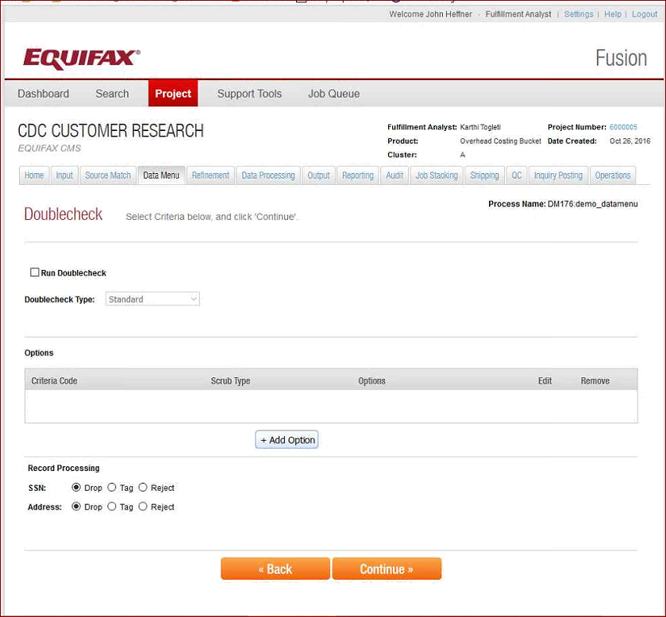

Here we can add various options based on the criteria code. It also consists record processing.

## Data menu Filter and Configuration page

The data menu filter and configuration page comprises of the filters applied to the process. It also tells the sequence on which the steps needs to execute

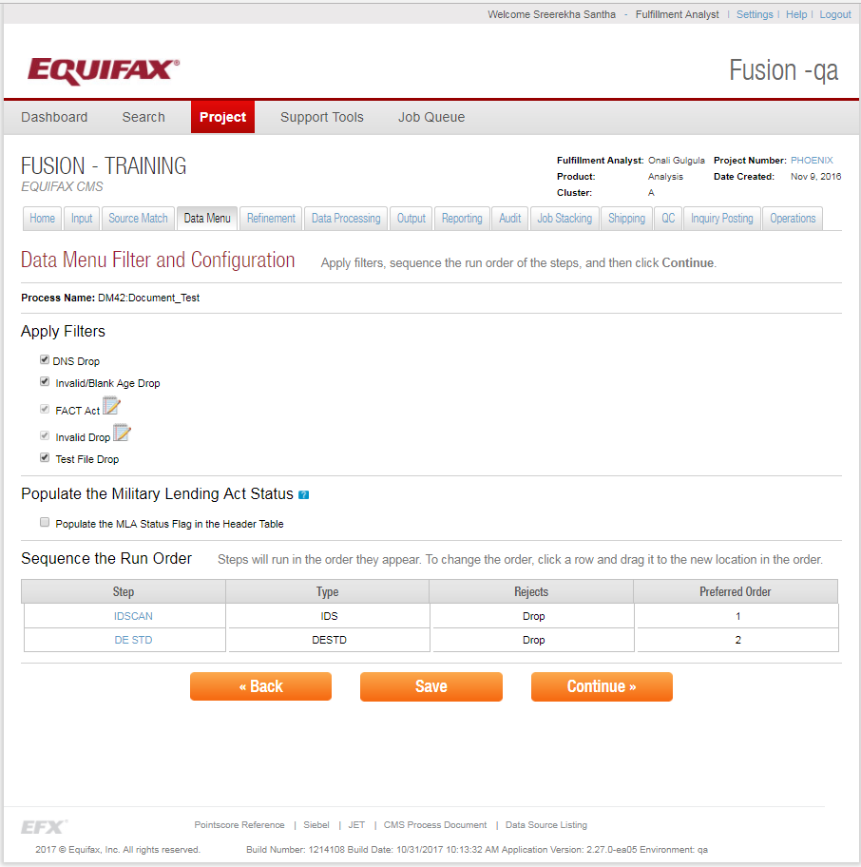

**Apply Filters**

The filters needs to apply in the process include – DNS Drop, Invalid/Blank Age Drop, FACT Act, Invalid Drop and Test File Drop.

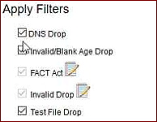

* **DNS Drop** – Drop the Do Not Solicit customer to prevent them sending promotional offers
* **Invalid/Blank Age Drop** – Drop the customers whose age is invalid of blank in the credit file
* **FACT Act** - Fraud Alert Contact. This is a law that was passed that requires that a consumer with a Fraud Alert on their file must be notified in writing when their credit file is accessed.
* **Invalid Drop** - If you click on the edit icon you’ll see a list of options that allow you to reject records with certain types of invalid data. Like invalid names/addresses/business addresses/etc.
* **Test File Drop** – Drop the test files in the DB

**Sequence the Run order**

Here, we can re-arrange the order of steps accordingly. For e.g. if we want to run the identity scan after the score calculation, move the IDSCAN to the last position.

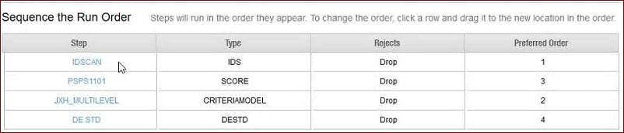

## Credit Input

Select the Credit data set to be processed among the list of golden/weekly/monthly/1%/100% data sets.

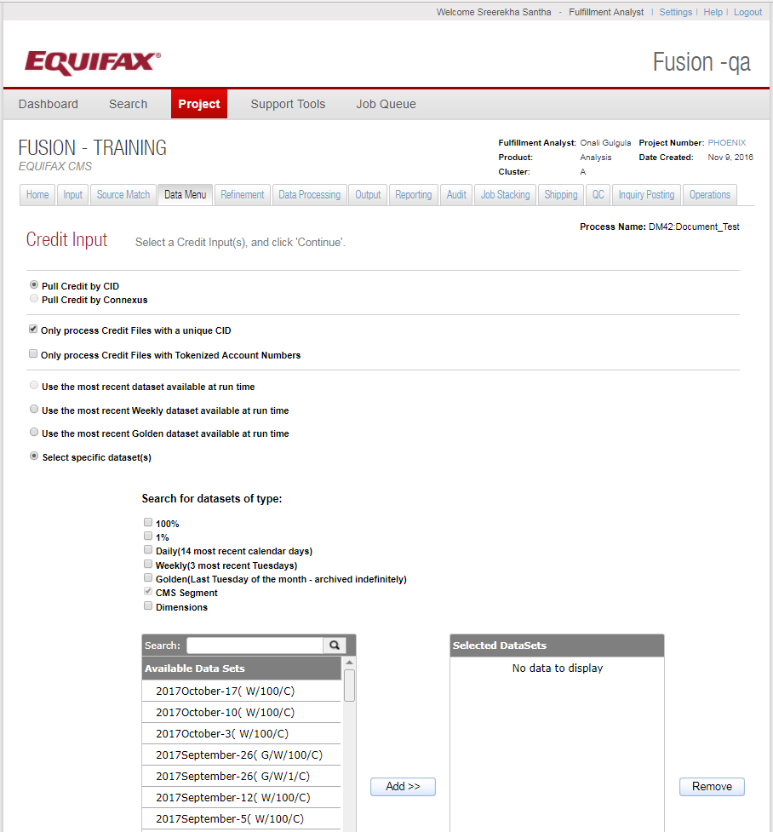

**Pull Credit By**



Opt whether to pull the credit information by CID (Credit ID) or the Connexus key (Key created based on the name and address, using the Connexus algorithm)

**Only Process Credit Files**



There are scenarios where the same CID’s may present in more than one credit files. In such scenarios, this option tells either to consider/ignore duplicate CID files.

**Use Most Recent**

It implies which credit dataset we need to use in the Data Pump.

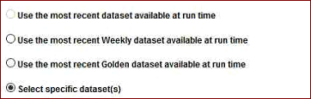

The available options are as follows:

* Use the most recent dataset available at run time: Once this option is selected, the Data Menu will run on the most recent copy of the ACRO files.
* Use the most recent Weekly dataset available at run time: It represents the last Tuesday’s file.
* Use the most recent Golden dataset available at run time: It represents the file from the last Tuesday of the month. Golden copies of the datasets are kept forever.
* Select specific dataset(s): The dataset can be 100% or 1% (1% of data for testing is created weekly) or Daily or Weekly or Monthly or Dimensions (Different data source of every 24 months records). We can add the datasets using the Add button. When multiple datasets are selected, separate datapump job is submitted using the same configuration for each dataset selected.

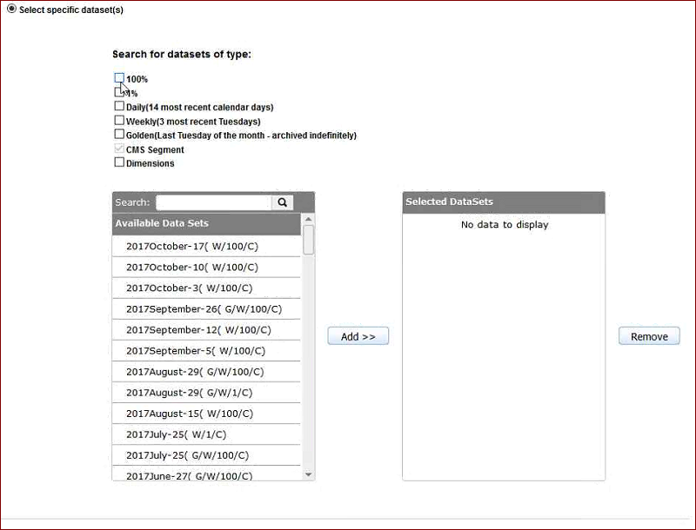

## Summary

Summary page provides the summary of all the selections we made in the previous steps. The summary page has the provision to view the job XML created. This is passed to the JET for further operations

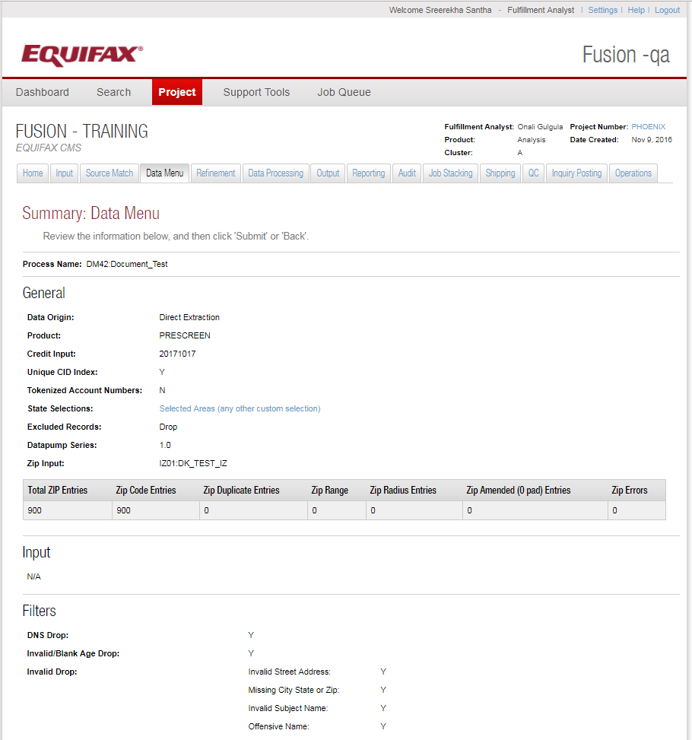

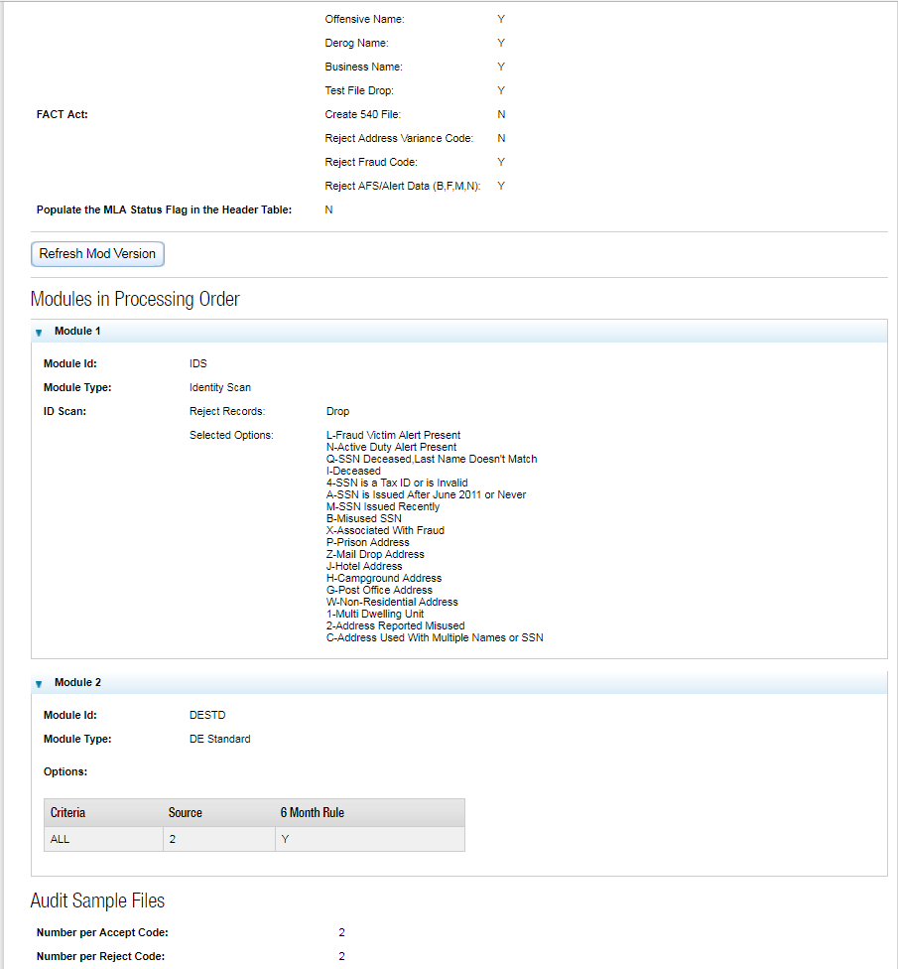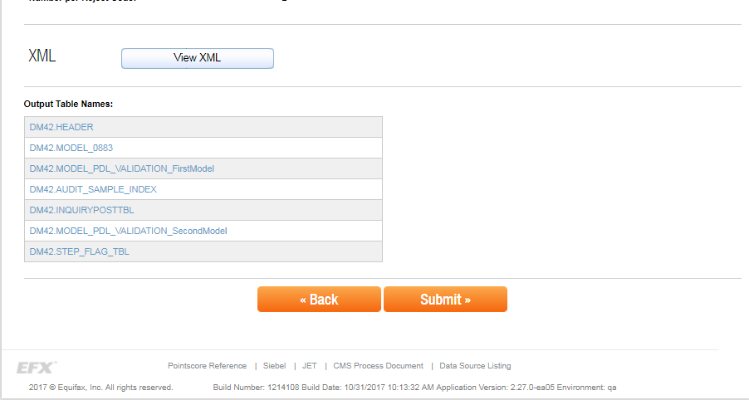

**View XML**

It contains all the details like the Job name, the credit data set needs to be used, the output tables etc. The XML is being used by the operations team for further processing.

